|  |  |
| --- | --- |
| A picture of a winding road and trees  Ai-RPA Based Seo and digital marketing | Abstract  The basic idea of this project is to optimize the SEO (Search Engine Optimization) using AI and RPA to reduce the time and weight from the client and making SEO a total automatic procedure and lift the site and interface with potential customers and business contacts.  Shagun goel, Peeyush Gupta, Krishna Bansal, Vijay Bhasin. |

Table of Contents

[Agile Manifesto:- 3](#_Toc33738735)

[• Individuals and interactions 3](#_Toc33738736)

[• Working software 3](#_Toc33738737)

[• Customer collaboration 3](#_Toc33738738)

[• Responding to change 3](#_Toc33738739)

[4](#_Toc33738740)

[Principles behind agile manifesto:- 4](#_Toc33738741)

[Problem Statement: - 5](#_Toc33738742)

[Introduction 6](#_Toc33738743)

[Search Engine Optimization:- 6](#_Toc33738744)

[NLP:- 6](#_Toc33738745)

[RPA:- 6](#_Toc33738746)

[• Responding To Change: - 8](#_Toc33738747)

[ER-Diagram: - 9](#_Toc33738748)

[1. SEO: - 9](#_Toc33738749)

[2. RPA: - 10](#_Toc33738750)

[3. AI-RPA Based SEO:- 11](#_Toc33738751)

[11](#_Toc33738752)

[Data Flow Diagram: - 11](#_Toc33738753)

[11](#_Toc33738754)

[METHODOLOGY 12](#_Toc33738755)

## Agile Manifesto:-

We are uncovering better ways of developing software by doing it and helping others do it. Through this work we have come to value:

* Individuals and interactions over processes and tools
* Working software over comprehensive documentation
* Customer collaboration over contract negotiation
* Responding to change over following a plan

That is, while there is value in the items on the right, we value the items on the left more.

|  |  |  |
| --- | --- | --- |
| Kent Beck Mike Beedle Arie van Bennekum Alistair Cockburn Ward Cunningham Martin Fowler | James Grenning Jim Highsmith Andrew Hunt Ron Jeffries Jon Kern Brian Marick | Robert C. Martin Steve Mellor Ken Schwaber Jeff Sutherland Dave Thomas |

## Principles behind agile manifesto:-

* Our highest priority is to satisfy the customer  
  through early and continuous delivery  
  of valuable software.
* Welcome changing requirements, even late in  
  development. Agile processes harness change for  
  the customer's competitive advantage.
* Deliver working software frequently, from a  
  couple of weeks to a couple of months, with a  
  preference to the shorter timescale.
* Business people and developers must work  
  together daily throughout the project.
* Build projects around motivated individuals.  
  Give them the environment and support they need,  
  and trust them to get the job done.
* The most efficient and effective method of  
  conveying information to and within a development  
  team is face-to-face conversation.
* Working software is the primary measure of progress.
* Agile processes promote sustainable development.  
  The sponsors, developers, and users should be able  
  to maintain a constant pace indefinitely.
* Continuous attention to technical excellence  
  and good design enhances agility.
* Simplicity--the art of maximizing the amount  
  of work not done--is essential.
* The best architectures, requirements, and designs  
  emerge from self-organizing teams.
* At regular intervals, the team reflects on how  
  to become more effective, then tunes and adjusts  
  its behaviour accordingly.

# Problem Statement: -

As the world is moving ahead towards the modernization with the help of technologies everyone is busy with their daily routine. Due to which it is difficult to visit different websites and compare them. This problem will be understood better with the help of an example.

Suppose there is a student who lives in Dehradun has to book an appointment with the doctor at Aims Delhi so first he books the appointment and then he has to wait for the appointment to be confirmed by the doctor. After that he proceeds with the booking of hotels, decides his travel mode, and books the cab and many other things. So he spends most of his time in the after process of appointment and has to do a lot of comparison to get a best deal.

# Introduction

PERSONAL VIRTUAL ASSISTANT

So here we are with a solution of personal virtual assistant to this problem discussed above. This helps the user to reduce his work. Lets take the problem discussed above suppose the student gets the confirmation of the doctor so personal virtual assistant will be active and when the student opens the mail it will also read it and will take the further steps like personal virtual assistant will search for cheap flights and compare them same thing happens with the hotels and cabs and display it on the student’s (users) screen as a notification so that he can just click on it and confirms the bookings. Through this he saves his time and the work is also not delayed.

### NLP:-

Natural Language Processing is a subfield of linguistics, software engineering, data designing, and artificial intelligence concerned about the interaction among computers and human (natural) languages, specifically how to program PCs to process and analyse a lot of natural language information.

Difficulties in natural language preparing frequently include speech recognition, natural language understanding, and natural language generation.

### RPA:-

Robot Process Automation is the technology that allow anybody today to configure computer software, or a "robot" to imitate and coordinate the activities of a human connecting with digital systems to execute a business procedure. RPA robots use the User interface to catch information and control applications simply like people do. They interpret, trigger responses and communicate with different systems so as to perform a vast variety of repetitive task. Just generously better: a RPA programming robot never rests and commits zero errors.

So the primary thought is to reduce the time and weight from the client and making SEO a total automatic procedure and lift the site and interface with potential customers and business contacts.

In order to make any project successful the one should apply the agile principles so that the software come in a superior manner. Our prime goal is customer satisfaction. So we will apply this principles in the project so that the project become efficient and effective. First principle is:-

* Individuals and Interactions:-

The first principle says Individuals and interactions over process and tools. In order to make a website efficient the developer should interact with the people, discuss with them and then make a working software. Let us take an example: suppose the developer has make a website for Bikaner. In his rivalry Haldirams has also make the website. Now both the websites will show the detail of the food items, sweets, bakery and various types of Indian snacks and also show the price as per the item. Now suppose user want to eat something. He type sweet and food in. Now suppose at first the Haldiram website pop up before Bikaner. Then obviously the user will first visit the recommended website. So in this case there may be a loss for Bikaner until and unless the user only want to have a food from Bikaner because instead of having a better taste and less price as compared to Haldiram the user order from Haldiram.

So in order to display our website on top of search we have to add some special keywords in our website and have to search it again and again. But this process of keyword and search takes a lot of time and instead of giving a good interface to website the developer is busy in finding the keyword. So to remove the burden on developer we will use RPA. We will assign all this work to a robot and function the robot using AI (Artificial Intelligence). The robot will do all this work and the developer can interact with other website and people in order to make the website user friendly and effective.

* Working Software:-

The second principle says Working Software over comprehensive documentation. Do you sometimes feel like your group is investing more energy in documenting your system rather than building it? Hence one of the major obstacle to progress in a software project is documentation. The Agile Manifesto recommends that groups should value working software over far reaching documentation. It does not mean that you should not focus on documentation, it implies that you should make documentation that offers some value and simultaneously does not hinder the team project. Composing documentation particularly towards the start of a project has numerous drawbacks. Delivering the software that does what it should come first in the priorities before creating documentation, so as per the meaning we should provide a software which will help the users in ranking their websites. For ranking a website we need a software which is called as SEO tool or keywords. There are many SEO keywords available on internet such as SEMrush, MOZ Pro, Conductor, SE Ranking, etc.

What is the work of keyword?

The work of these keywords is to investigate the potential of Web pages for high placement on search engine ranking pages. They provide information on backlinks and keywords as well as insights into competition on the Internet. Web optimization apparatuses (the technical equipment or machinery needed for a particular activity or purpose) help site proprietors to rank higher in web crawler results.

* Customer Collaboration:-

The third principle says Customer collaboration over contract negotiation. As nowadays if someone searches for sth on the web then in the results the first those things come up with Ads or are affected with virus and many other things which can waste the time of customer with the accurate results. So using Ai and RPA is a website booster site views and business growth. It is increasing the visibility of website or web page to users of a web search engine. It shows natural results and excludes direct traffic. So as are statement says that customer collaboration is a customer who is purchasing your solution so as in the market today it is important to understand the customer needs and satisfy them so are project also deals with this thing as our priority is customer satisfaction first. This is how we can relate this statement with our plan.

## Responding To Change: -

The fourth principle says to respond to change. Breakdown of work into small chunks is one thing that we do in this principle. Suppose a big change come into a project the development team doing the work can drop their work and quickly respond to the change. This principle allows make you flexible and enhance you so that you can solve the bigger problems coming up.

# ER-Diagram

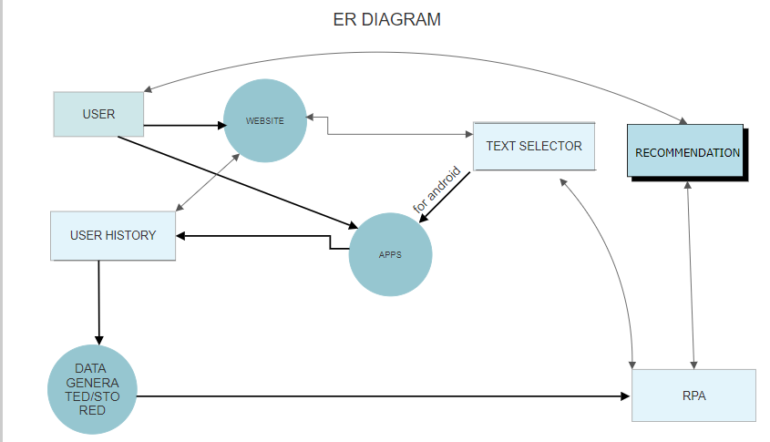

### RPA: -

### AI-RPA Based SEO:-

# Data Flow Diagram: -

# C:\Users\Admin\Desktop\Presentation_H4\AGILEdataf.PNG

# METHODOLOGY